7COM1079-0901-2025 - Team Research and Development Project

Final report title: “Correlation Analysis of Cost of Living and Rent Index Using 2022 Data”

Group ID: A 124

Dataset number: DS 155

Prepared by:
Kodeboyina Varsha 24178294
Sangam Bala Venkata Naga Ravindranath 24179368
Chiru Naga Pavan Kamandula 23116877
Keerthika Chowdary Nidamanuri 24155147
Attada Tintu Sai Mohan 24181282

University of Hertfordshire
Hatfield, 2025

Table of Contents
1. Introduction 3
1.1 Problem Statement and Research Motivation 3
1.2 The Data Set 3
1.3 Research Question 3
1.4 Null and Alternative Hypotheses 3
2. Background Research 3
2.1 Research Papers 4
2.2 Why the Research Question Is of Interest 4
3. Visualisation 5
3.1 Appropriate Graphs for the Research Question 5
3.2 Additional Information Relating to Understanding the Data 5
3.3 Useful Information for Data Understanding 5
4. Analysis 5
4.1 Statistical Test Used and Output 5
4.2 Hypothesis Decision Based on p-value 5
5. Evaluation – Group Experience 6
5.1 What Went Well 6
5.2 Points for Improvement 6
5.3 Group’s Time Management 6
5.4 Project’s Overall Judgement 6
6. Conclusions 6
6.1 Results Explained………………………………………………………………………6

6.2 Interpretation of the results………………………………………………………………6

6.3 Reasons and /or Implications for future work, limitations……………………………....6

7. Reference List 7
8. Appendices 7
Appendix A – R Code 7
B- Github log Output………………………………………………………………………..8

- Introduction
  - Problem statement and research motivation
Across many countries, the increasing cost of living has become a major concern for households, governments, and students. Among these costs, rent remains one of the main factors affecting financial pressure. Understanding whether higher living costs are linked to higher rent prices can help policymakers create support programs, assist students with budgeting and allow families to compare affordability across countries. Previous studies point to adding housing burdens worldwide, but many do not directly compare the cost-of-living index with the rent index. Analysing their correlation is important to understand global affordability trends and the economic pressure on the population.

  - The data set
The dataset used in this study is a global Cost-of-Living dataset that includes countries, the Cost-of-Living Index, Rent Index, Cost of Living plus Rent Index, Groceries Index, Restaurant Price Index, and Local Purchasing Power Index. For this project, only two variables were analysed: the 2022 Cost-of-Living Index and the Rent Index. These indices are commonly reported by similar sources, enabling consistent comparison between countries. The dataset provides numeric, continuous values suitable for statistical correlation analysis.

  - Research question
The main research question explored in this report is:
“Is there a correlation between the Cost-of-Living Index and Rent Index across countries in 2022?”
This question aims to determine whether higher living costs are associated with higher rent prices and whether these two economic indicators move together globally.

  - Null hypothesis and alternative hypothesis (H0/H1)
H0 (Null Hypothesis): There is no correlation between the Cost-of-Living Index and the Rent Index. If this hypothesis is true, changes in living costs occur independently of changes in rent, meaning that increases or decreases in one variable do not influence the other variable.
H1 (Alternative Hypothesis): There is a correlation between the Cost-of-Living Index and the Rent Index. A positive correlation is anticipated, suggesting that countries with higher living costs also tend to experience higher rent levels. Testing these hypotheses helps to determine whether the two indicators are statistically connected and whether a meaningful relationship exists.

- Background research
  - Research papers (at least 3 relevant to your topic / DS)
Research consistently demonstrates that rent is one of the primary factors influencing overall living costs across countries. Nor et al. (2025) found that the Cost-of-Living Index plays an important role in shaping rental prices, suggesting a strong and measurable relationship between general living expenses and the cost of accommodation. Their findings indicate that increases in living costs are frequently mirrored by increases in rent, particularly in regions facing economic pressures or environmental challenges. Similarly, Dougherty and Van Order (1982) emphasise that housing costs are a major component of consumer price indices, noting that accommodation expenses significantly influence national measures of inflation and the general cost of living. Their research highlights how rent, as a core household expenditure, affects financial stability and contributes to broader economic conditions. Further evidence from Albouy et al. (2015) shows that rising rent levels place increasing financial pressure on households, contributing to heightened cost-of-living burdens in both urban and international contexts. Their work also highlights the influence of housing demand, wage limitations and urban development on rent increases, demonstrating how these factors intensify affordability challenges. Although existing studies recognise the strong influence of rent on living expenses, relatively few examine the direct statistical relationship between the Cost-of-Living Index and the Rent Index across countries. This gap highlights the importance of analysing whether these two indicators move together globally.

  - Why RQ is of interest (research gap and future directions according to the literature)
Although various studies have examined housing and living expenses, limited research directly analyses the relationship between the Cost-of-Living Index and the Rent Index across different countries. Nor et al. (2025) investigated rental markets but focused on several determinants rather than isolating the global cost–rent relationship. Dougherty and Van Order (1982) discussed the significance of housing costs within inflation but did not undertake cross-country index comparisons. Albouy et al. (2015) connected rising rents to growing affordability challenges, yet without analysing international index patterns. Therefore, a clear gap remains in understanding whether cost-of-living and rent measures consistently move together globally.

- Visualisation
  - Appropriate plot for the RQ output of an R script (NOT a screenshot) and required supplementary graph/table
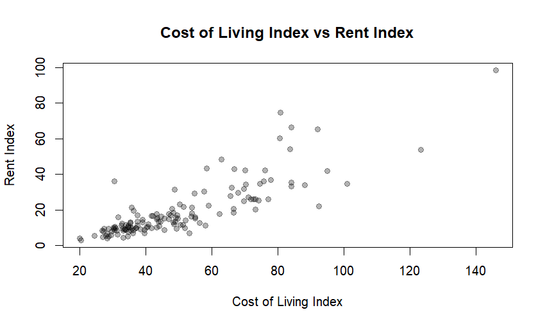

Figure 1: Relationship between the Cost-of-living index and the Rent Index across countries

A scatter plot was selected as it clearly illustrates the relationship between the Cost-of-Living Index and the Rent Index across countries.

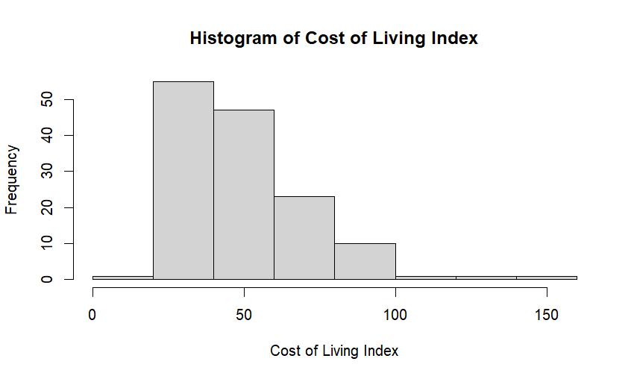
Figure 2 : The distribution patterns of the Cost-of-living index and Rent index across countries

Histograms were also included to show the distribution and shape of each variable, helping identify skewness and confirming that Pearson correlation is an appropriate statistical method.

  - Additional information relating to understanding the data
The scatter plot helps identify whether countries with high living costs cluster in the high-rent region.
Outliers with unusually high values can also be observed. Histograms reveal whether the indices follow a normal distribution or show skewness, which is important for validating the use of Pearson correlation

  - Useful information for the data understanding
Most countries fall within the 20–80 range for the Cost-of-Living Index, while only a few display exceptionally high rent values. The scatter plot shows a clear upward trend, indicating a positive relationship. The distribution patterns confirm that Pearson correlation is suitable, given the continuous, interval-scaled variables.

- Analysis

Statistic | Value
Correlation coefficient (r) | 0.8380788
P-value | < 0.001
Test type | Pearson correlation
Variables analysed | Cost-of-living index , Rent index
Sample size (n) | 139

  - Statistical test used to test the hypotheses and output
Pearson correlation was selected because both the Cost-of-Living Index and the Rent Index are numeric, continuous variables appropriate for assessing linear relationships. This test measures both the strength and direction of association between the two indicators. Pearson correlation is particularly suitable when the data meet interval-scale requirements and do not display extreme deviations from normality. Its use ensures that the relationship is evaluated accurately, making it an appropriate method for this analysis.

  - The null hypothesis is based on the p-value
The statistical test indicated a significant positive correlation with a p-value below 0.05, leading to the rejection of the null hypothesis. This demonstrates strong evidence that the Cost-of-Living Index and the Rent Index move together positively. In practical terms, countries with higher living costs generally experience higher rent levels, suggesting that rent contributes substantially to overall living expenses. Although correlation does not imply causation, the finding highlights an important economic relationship. These results can assist policymakers, students relocating internationally, and individuals comparing affordability across countries by providing clearer insight into how living costs and rent pressures interact globally.

- Evaluation – group’s experience at 7COM1079
  - What went well
Our group collaborated effectively through regular communication and a clear division of tasks. GitHub supported efficient version control, allowing us to track progress and prevent file conflicts. Data cleaning and preparation were completed smoothly, with all members contributing to discussions on statistical choices. The plotting process was well organised, and any issues were resolved collectively. Overall, teamwork was strong, and the final analytical output was accurate, clear, and completed within the planned timeframe.

  - Points for improvement
Time management needed improvement, as certain sections were completed close to the deadline. We also encountered difficulties interpreting early plot errors, which slowed our progress. Literature searching took longer than expected due to limited familiarity with academic databases. Improving early planning and assigning more specific responsibilities would help prevent delays in future projects. Additionally, clearer documentation of coding steps would support faster debugging and reduce confusion across the team, leading to a more efficient workflow.

  - Group’s time management
The group spent approximately 10 days completing the project. While communication was effective, some tasks were delayed due to plotting issues and slow literature review progress. Earlier planning could have distributed the workload more evenly. Despite time pressures, the group completed all tasks before the deadline.

  - Project’s overall judgement
The project provided valuable experience in handling large datasets, as well as conducting statistical tests and collaborating through GitHub. The results were meaningful and aligned with expectations based on previous literature. Overall, the project demonstrated effective teamwork, analytical skills, and understanding of correlation analysis in R.

- Conclusions
  - Results explained.
The analysis revealed a significant positive correlation between the Cost-of-Living Index and the Rent Index, indicating that higher living costs are associated with higher rent levels. The scatter plot and correlation coefficient clearly supported this upward relationship. These findings are consistent with expectations from previous research, which also highlights the strong influence of housing costs on overall living expenses. The results provide meaningful insight into how affordability pressures vary across countries and how rent contributes to broader economic conditions.

  - Interpretation of the results
The results indicate that rent plays a major role in shaping overall living costs, as countries with higher rent levels typically experience greater financial pressure on households. This relationship is particularly important for students, policymakers, and families assessing international affordability and planning budgets. The positive correlation also contributes to wider discussions on housing-driven inflation and the global challenges associated with rising living expenses. These findings highlight how rent significantly influences economic conditions across different countries.

  - Reasons and/or implications for future work, limitations
This study used only one year of data, limiting the ability to identify long-term trends. The analysis demonstrates correlation rather than causation. Future research could incorporate multi-year datasets, additional variables such as wages or purchasing power, and predictive modelling to provide a deeper understanding of global affordability patterns.

- Reference list
Nor, M.I., Audu, B. & Mohamed, A.D., 2025. Investigating the impact of property characteristics, cost of living, and environmental factors on rental prices in Baidoa’s climate-affected real estate market. Frontiers in Sustainable Cities, 7, pp.1–15.

Dougherty, A. & Van Order, R., 1982. Inflation, housing costs, and the consumer price index. American Economic Review, 72(1), pp.154–164.

Albouy, D., Ehrlich, G. & Liu, Y., 2015. Housing demand and expenditures: How rising rent levels affect behaviour and cost-of-living over space and time. NBER Working Paper, pp.1–59.

- Appendices
- R code used for analysis and visualisation.
# Set working directory
setwd("C:\\Users\\nravi\\Documents")
# Load dataset
analysis <- read.csv("Cost_of_Living_Index_2022.csv")
# View column names in the dataset
names(analysis)
# Select the Cost of Living Index and Rent Index for analysis
myanalysis <- analysis[c("Cost.of.Living.Index", "Rent.Index")]
# Create a scatter plot to visualise the relationship between the two indices
plot(
myanalysis$Cost.of.Living.Index,
myanalysis$Rent.Index,
pch = 19,
col = rgb(0, 0, 0, 0.3),
main = "Cost of Living Index vs Rent Index",
xlab = "Cost of Living Index",
ylab = "Rent Index"
)
# Perform Pearson correlation test
cor.test
myanalysis$Cost.of.Living.Index,
myanalysis$Rent.Index,
method = "pearson"
)
# Plot a histogram to examine the distribution of the Cost of Living Index
hist(
myanalysis$Cost.of.Living.Index,
main = "Histogram of Cost of Living Index",
xlab = "Cost of Living Index",
ylab = "Frequency"
)

- GitHub log output.

Commit 1: Add CSV version of Cost-of-Living index dataset for analysis

Commit 2: Add R analysis for Cost-of-Living vs Rent Index (Scatter plot, Histogram plot, Pearson Correlation).

Commit 3: Update visualisation: Add clean Scatter and Histogram plots.

Commit 4: Update research paper with final changes.

Commit 5: Final Template of Assignment.

